SERVICING MODULE BUYOUT TAWATTUQ
Unit Test Document Version 1.0
MARCH 17, 2026

Document History
Author | Version | Date | Description
Muhammad Ali  Muhammad Asad | V1.0 | 17th MAR 2026 | Initial Document

Contents
Arrangement Creation 4
Application Details 4
Buy-Out application creation 4
Qarar Response 5
Presales Queue 6
Application Overview 7
Transact Simulation 8
Financial Details 8
Simah Details 10
Application Approval 11
Offer Generation 14
Offer Acceptance 15
Application Details in Transact 16
STP Process 17
Bill Generation 18
Contract 18
Promissory Note 20
STP Complete 23
Arrangement 23
Arrangement’s Repayment Account 25
Disbursement 25

Arrangement Creation

Application Details
Application ID: CKNKN3K
Contract amount: 79,000
Contract Tenor: 24 Months

Buy-Out application creation
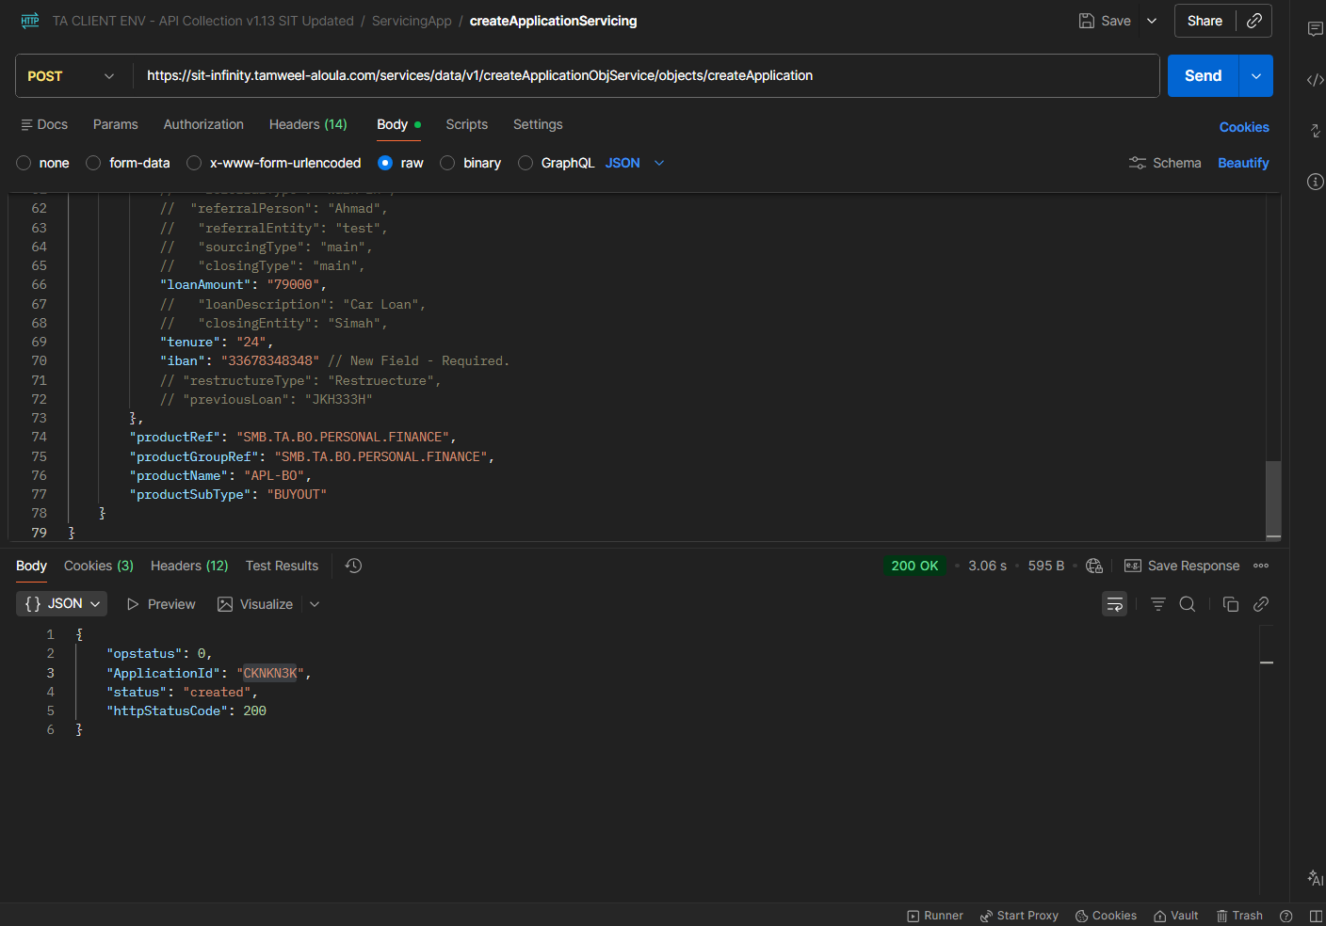
Application created from API
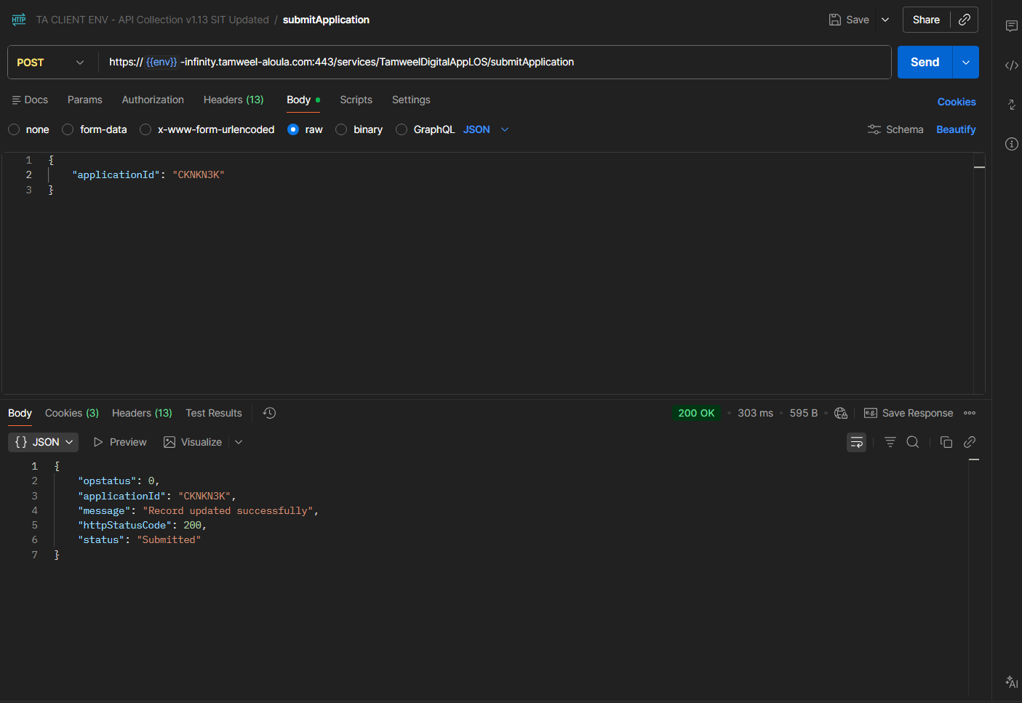
Application submitted through API

Qarar Response
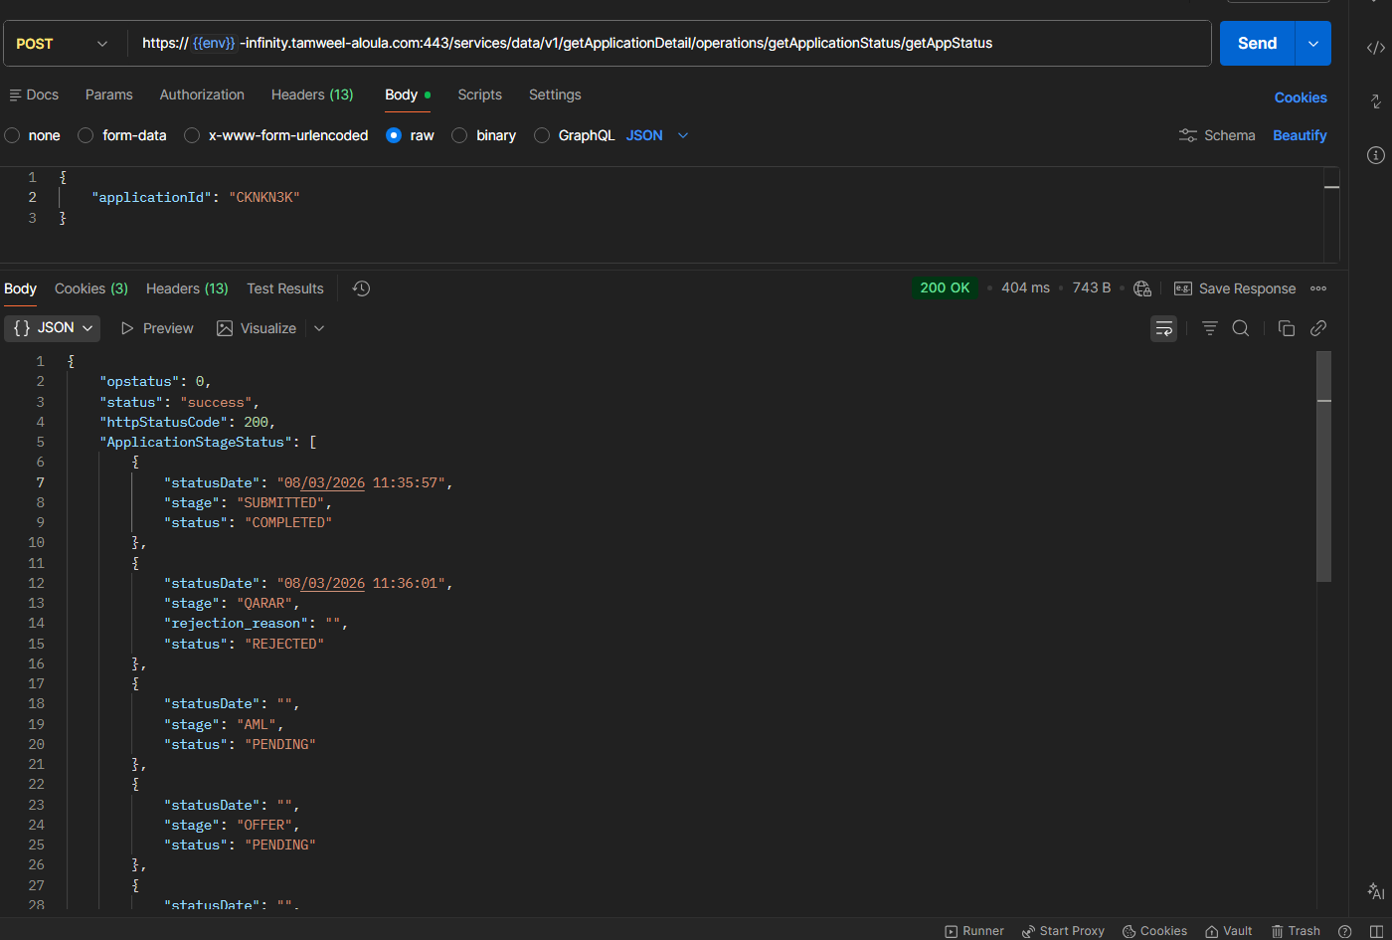
Qarar Response received

Presales Queue
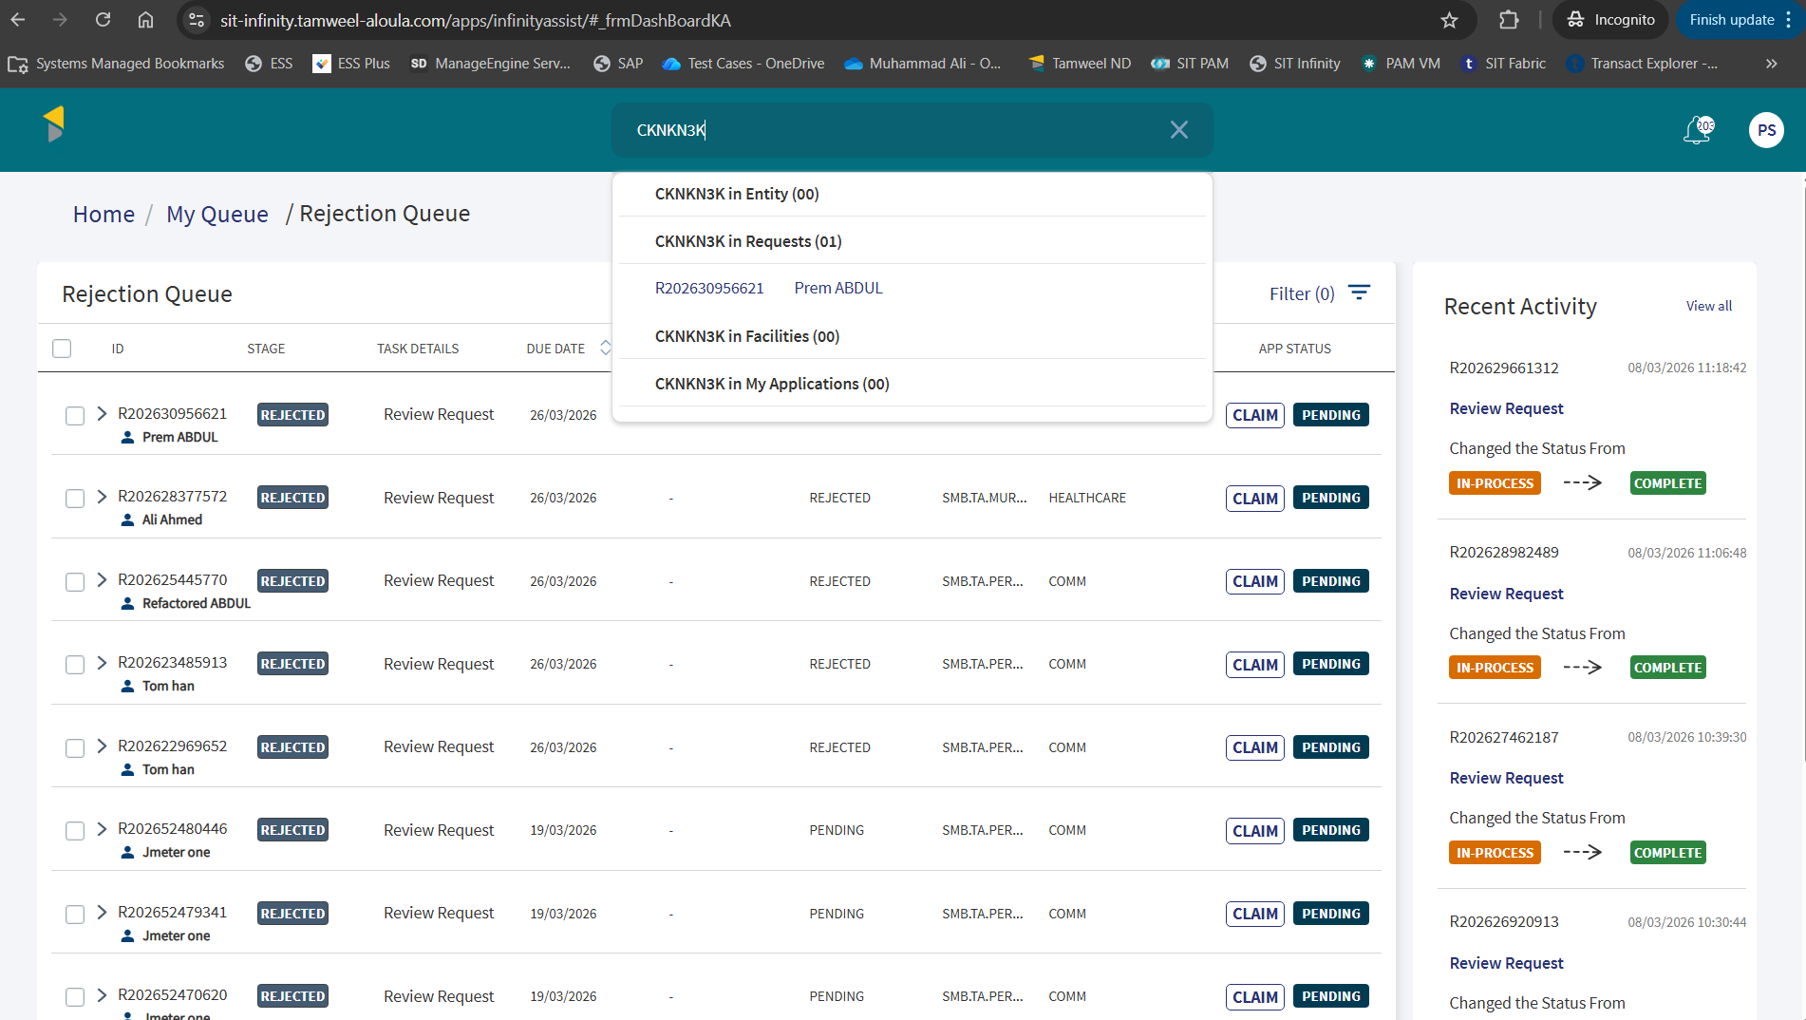
Application is visible in Presales Queue to claim
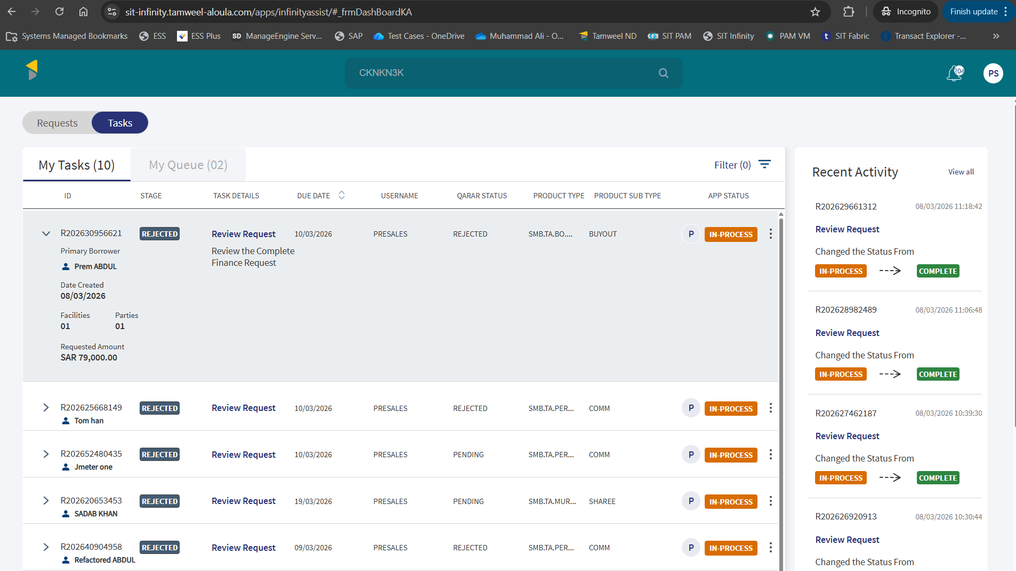
Application is claimed and appearing in My Tasks

Application Overview
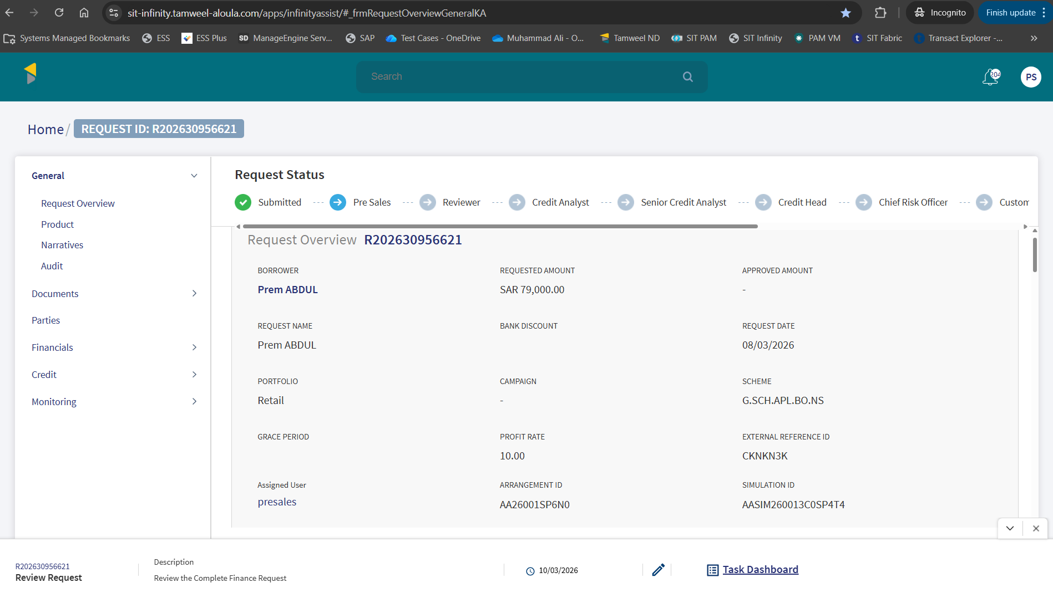
Request Overview details
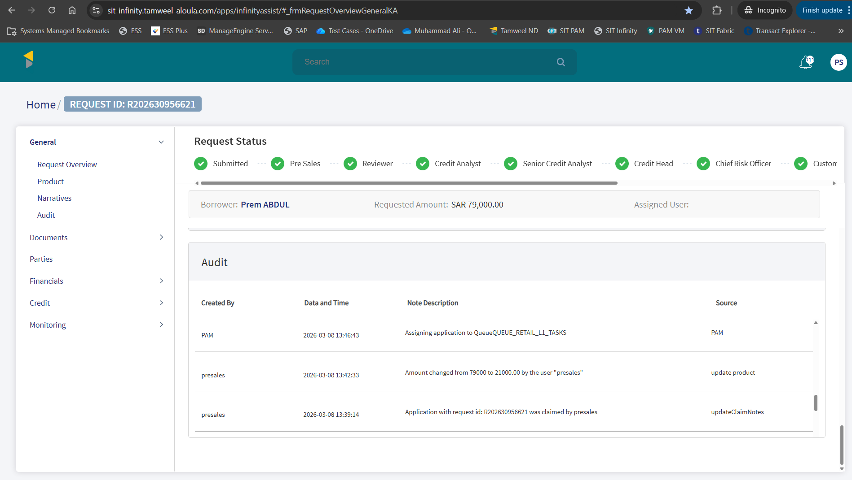
Request amount is changed from 79,000 to 21,000 by Pre-sales and can be seem in the Audit Log as well.

Transact Simulation
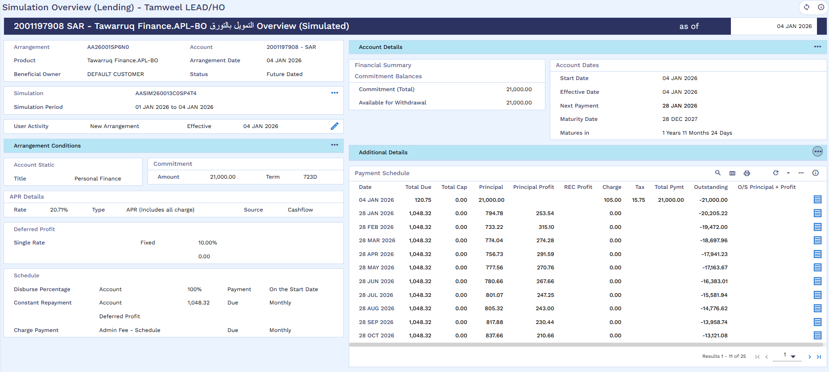
Simulation Created in Transact

Financial Details
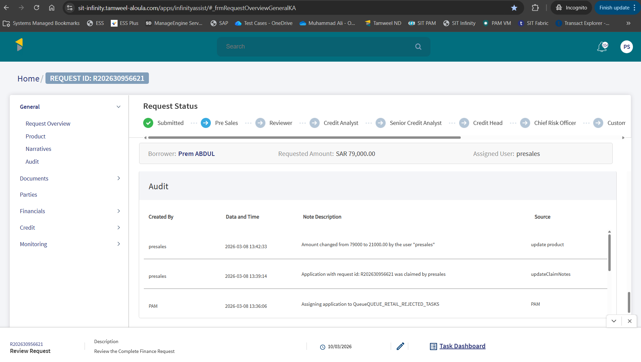
Audit log for application
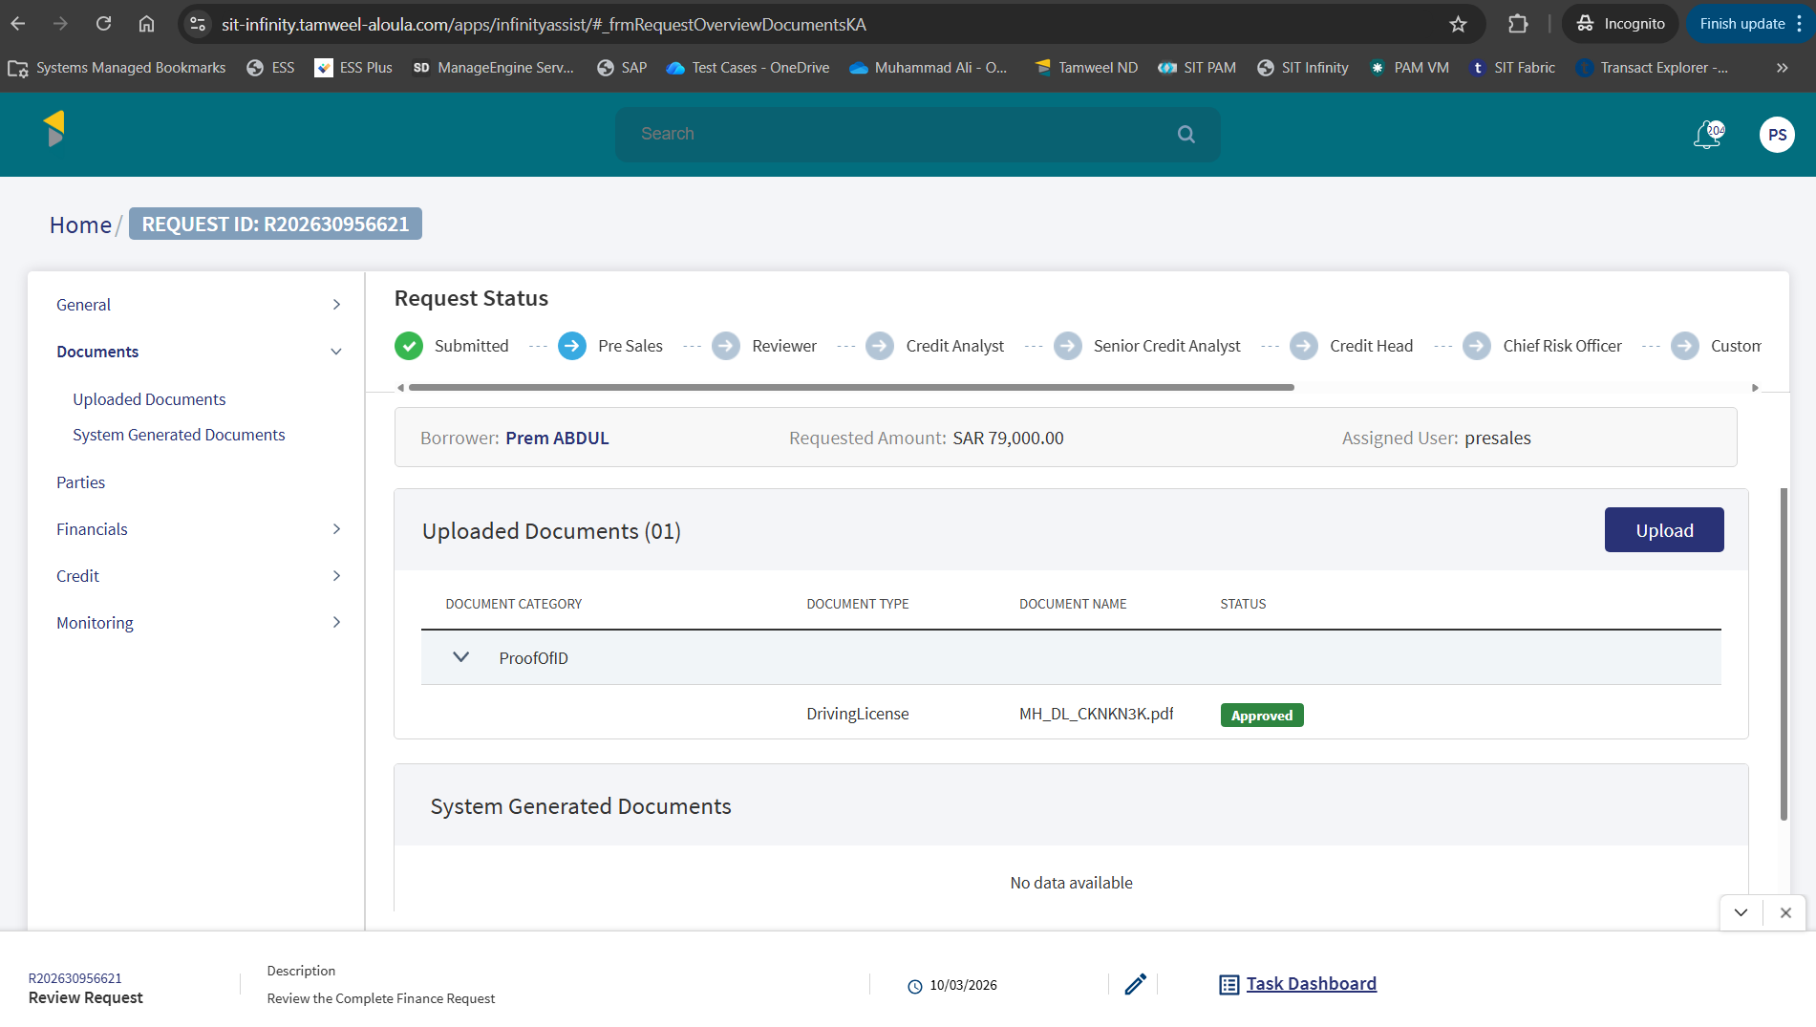
Document uploaded successfully
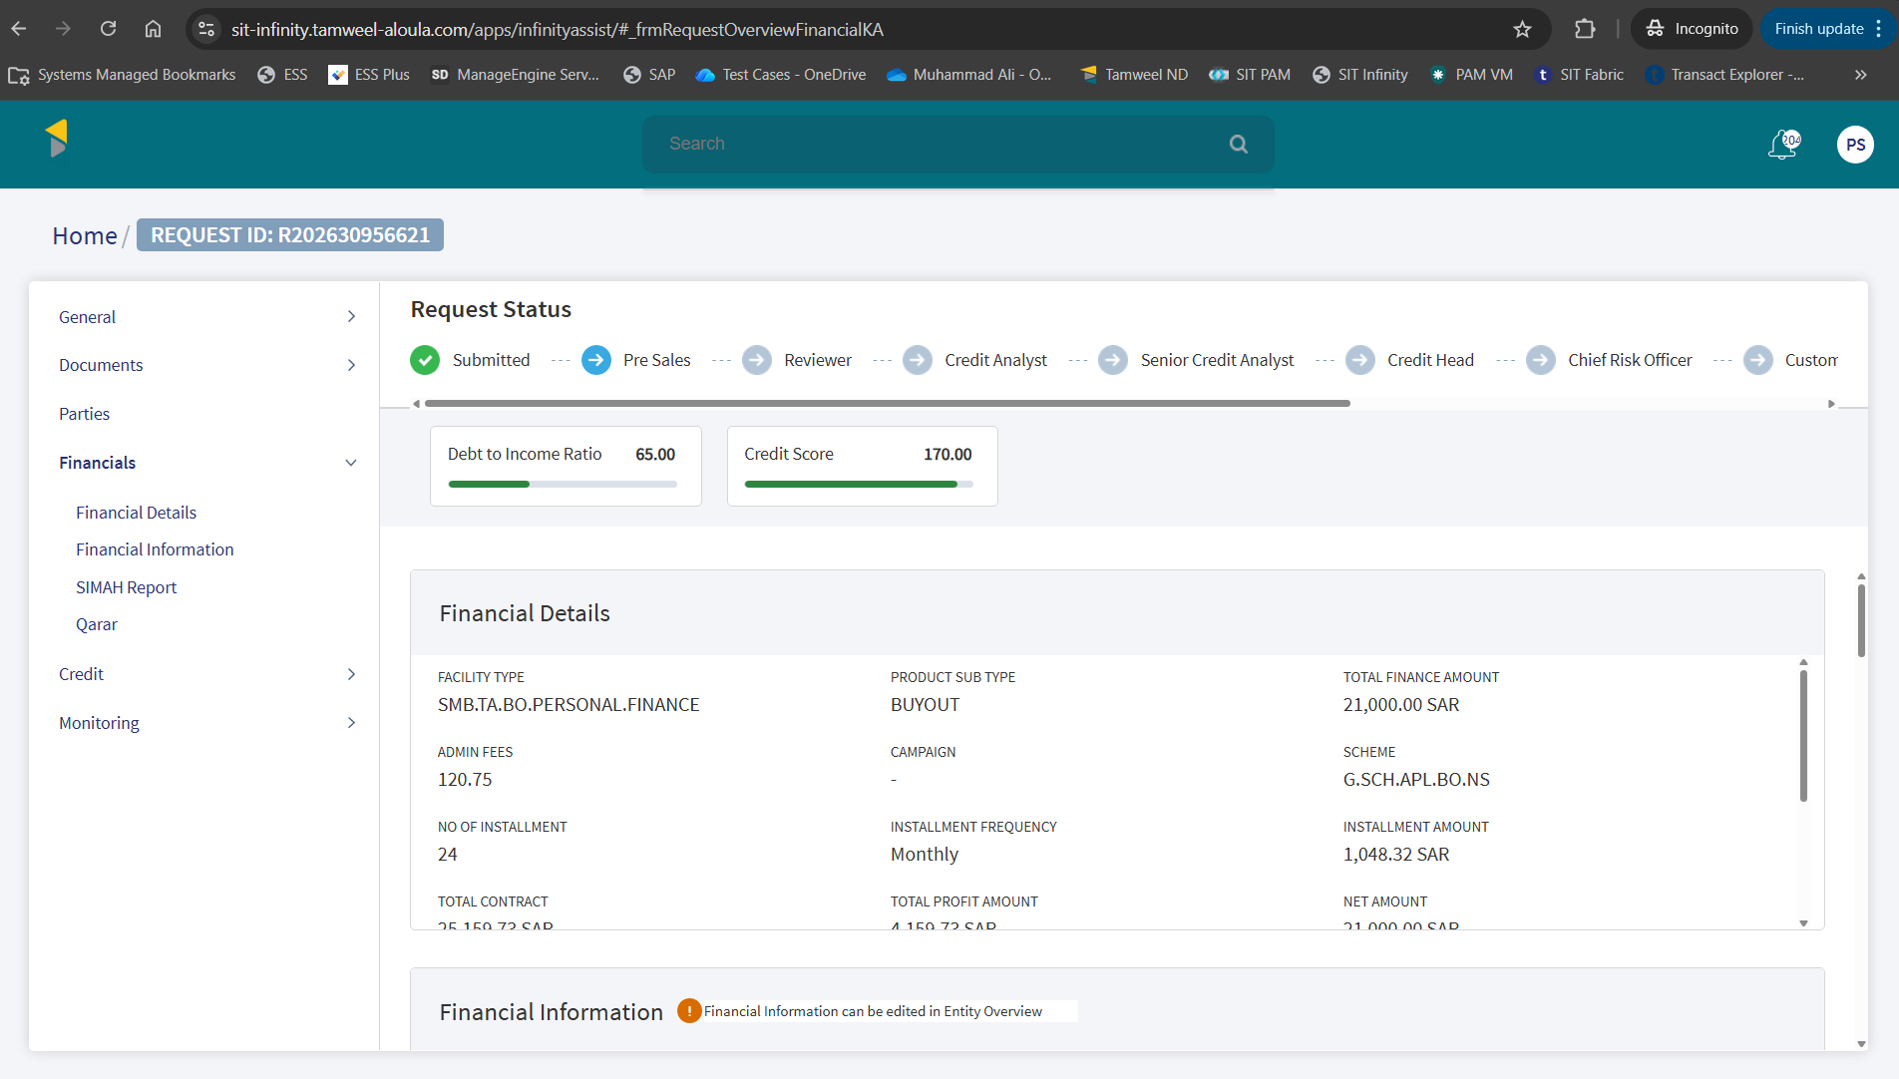
Financial Details of application
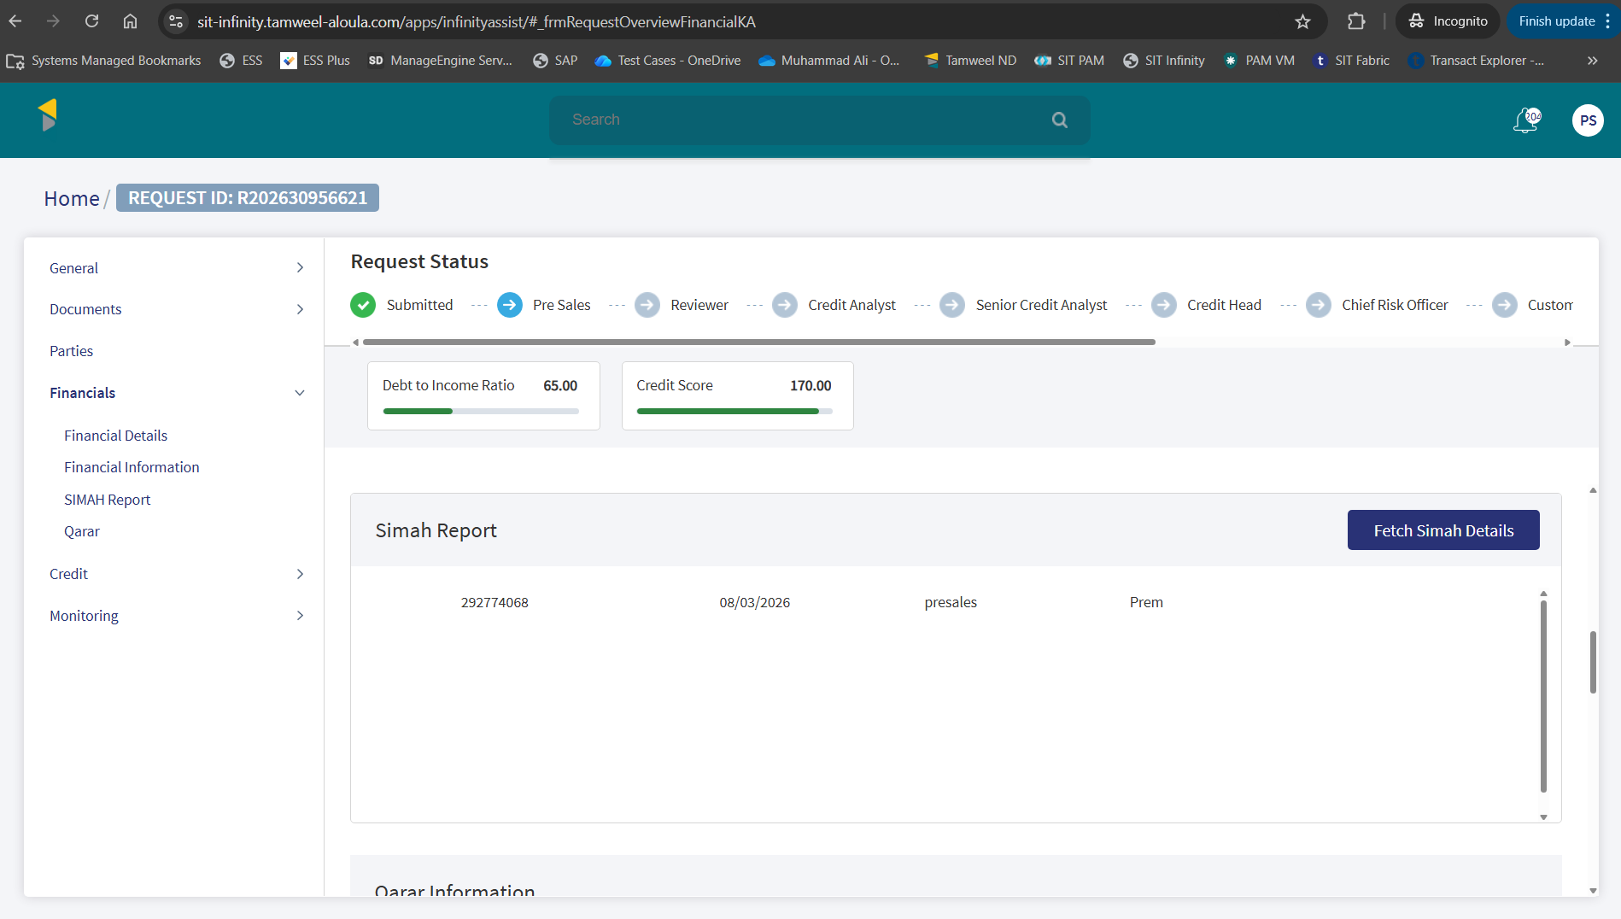

Simah Details
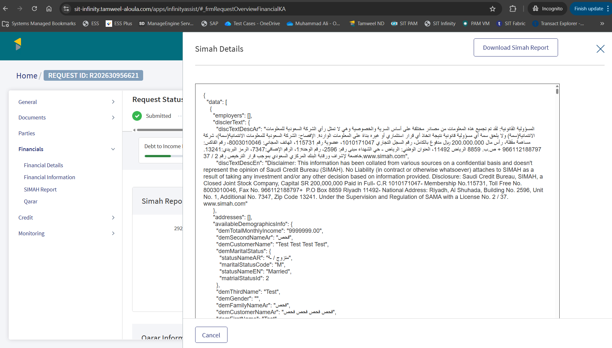
SIMAH report is available to download

Application Approval
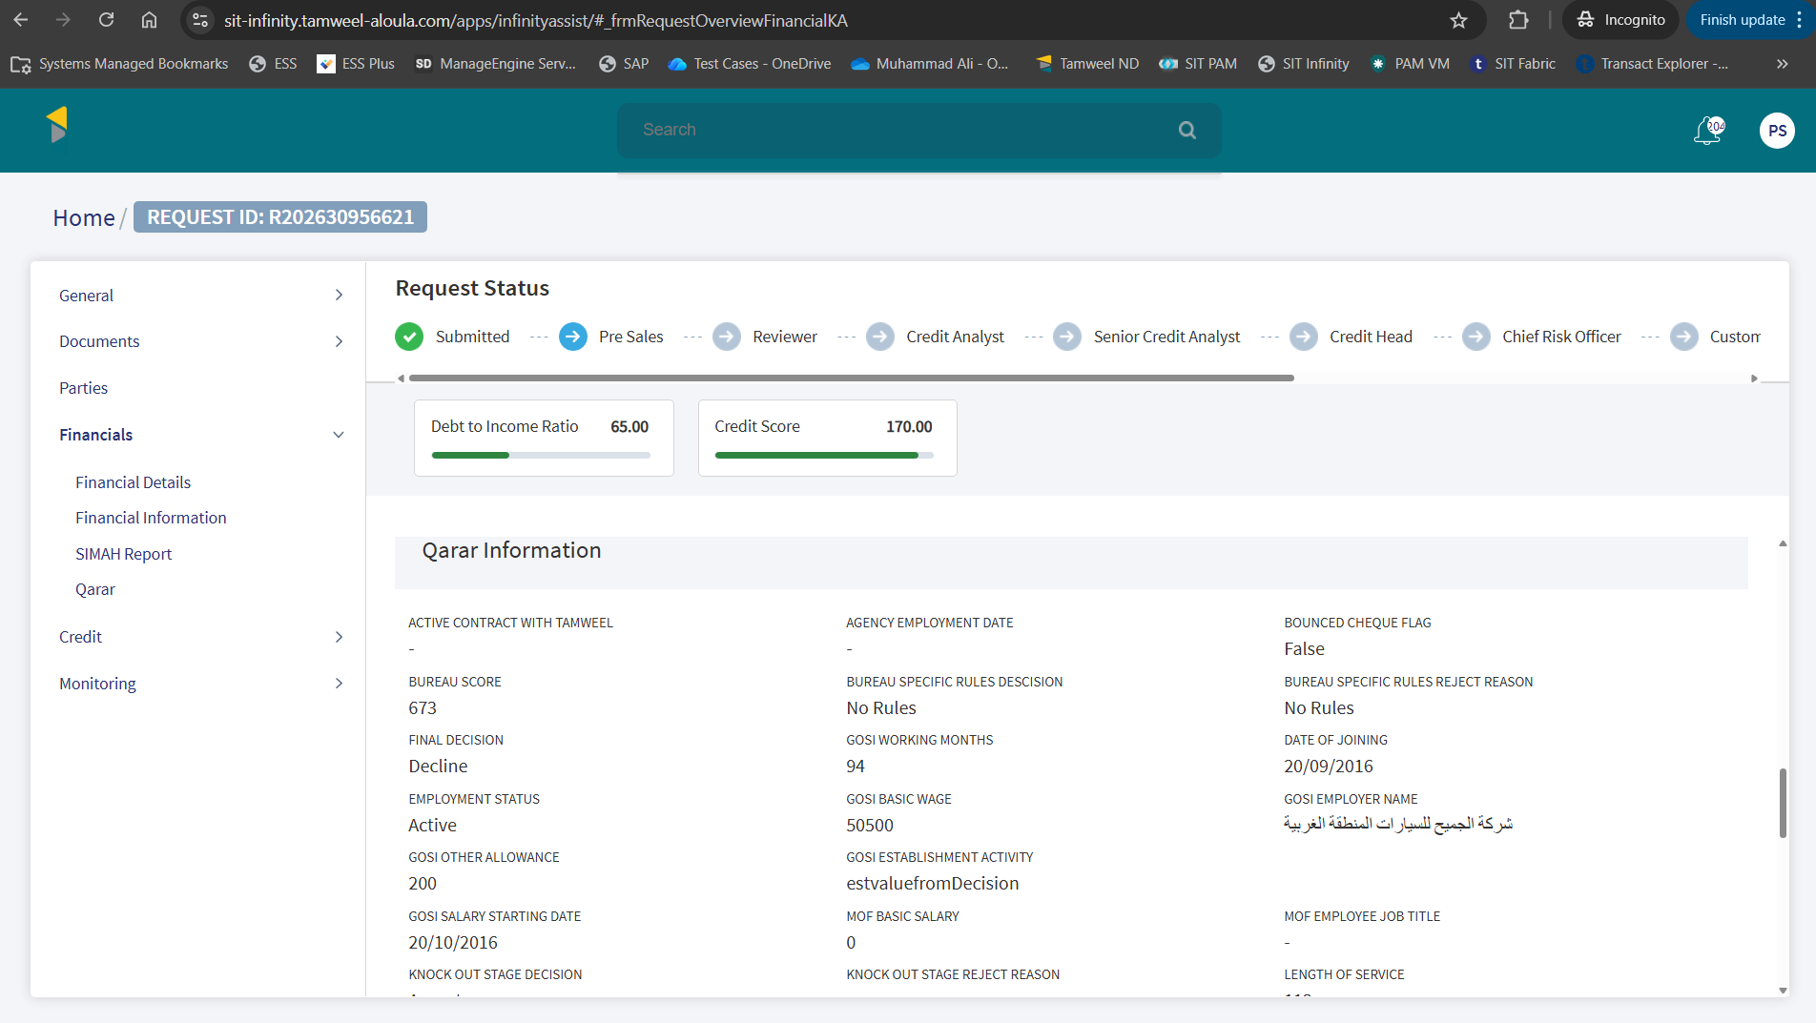
Qarar Information
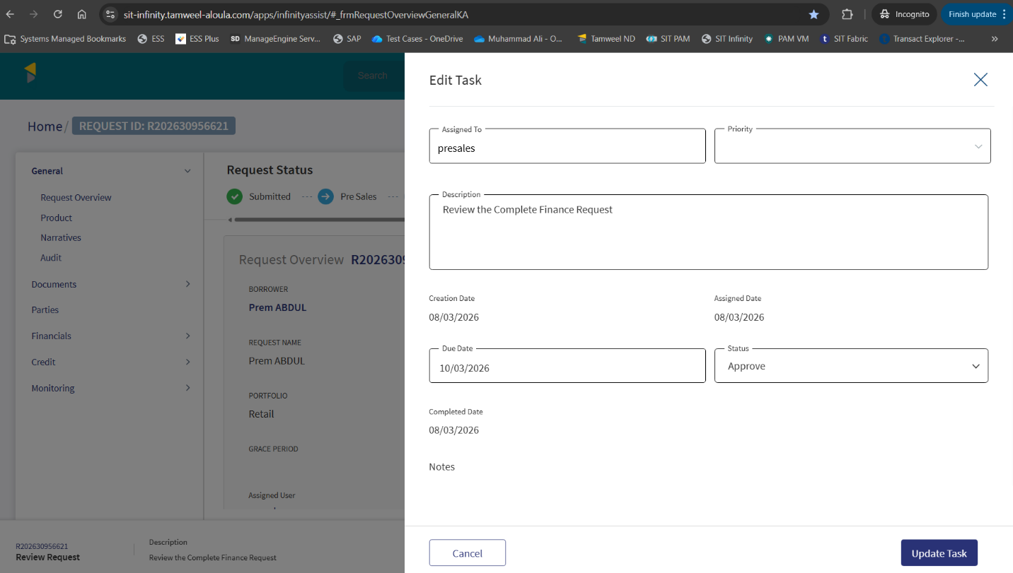
Application approved from Presales
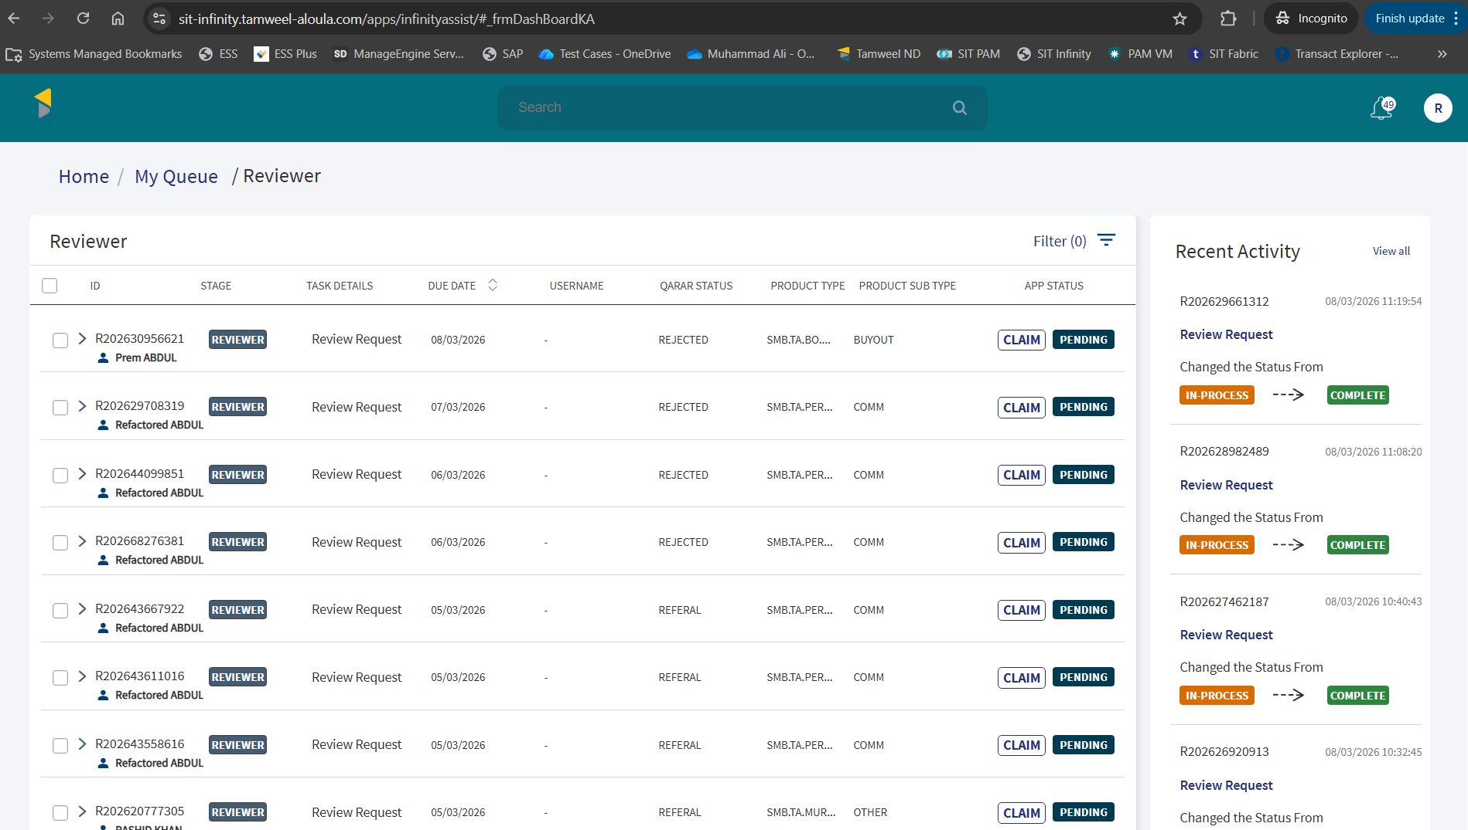
Application is visible in Reviewer’s queue to claim
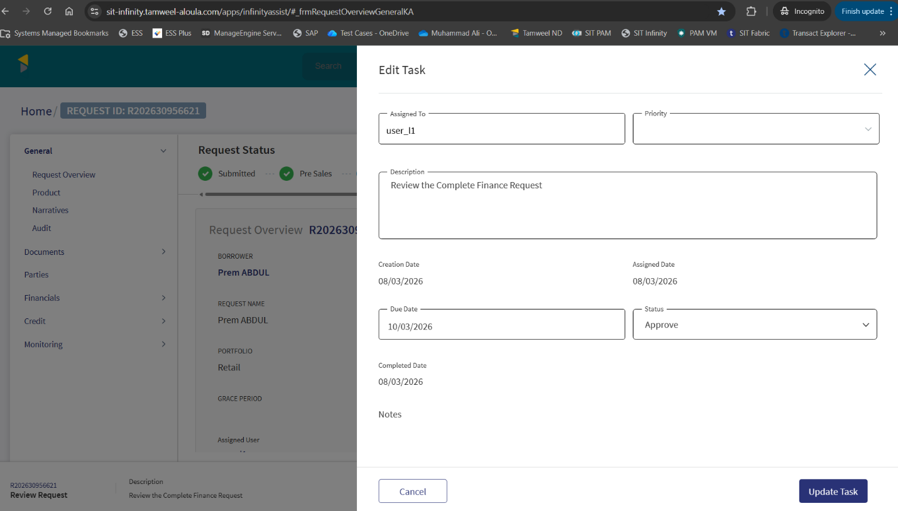
Application approved from Reviewer
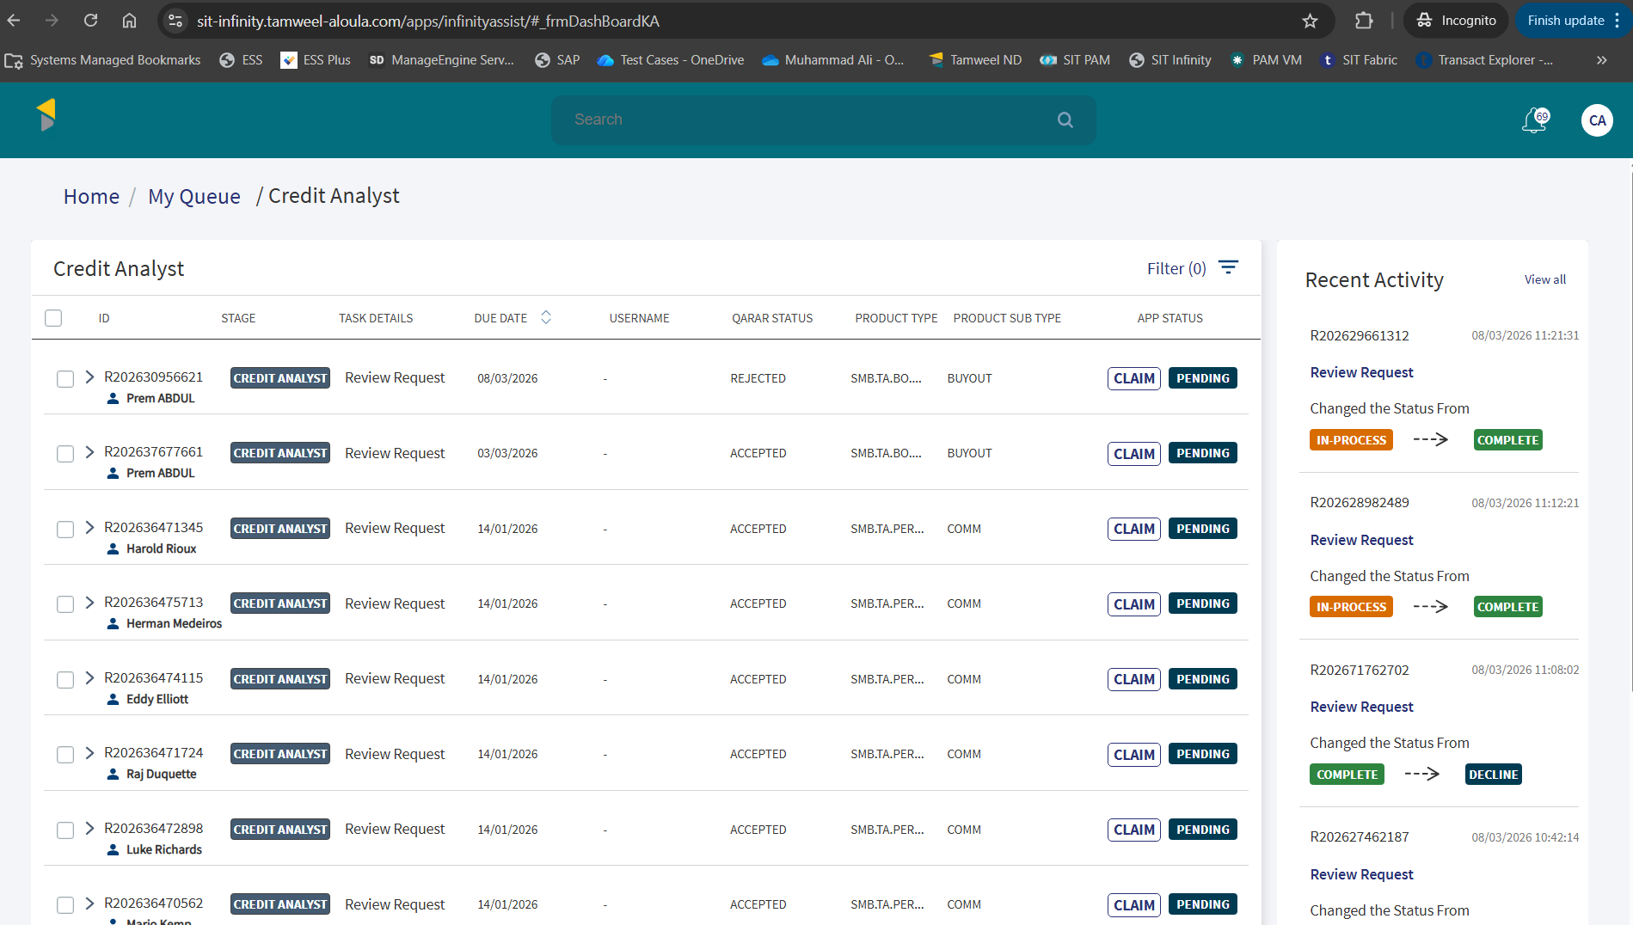
Application is available in Credit Analyst’s queue to claim
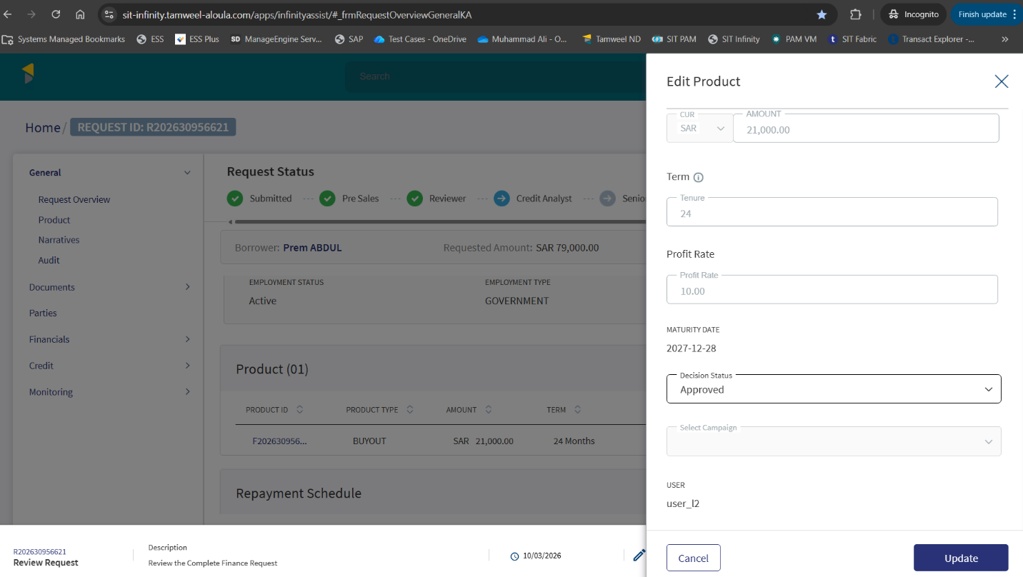
Loan amount approved from L2
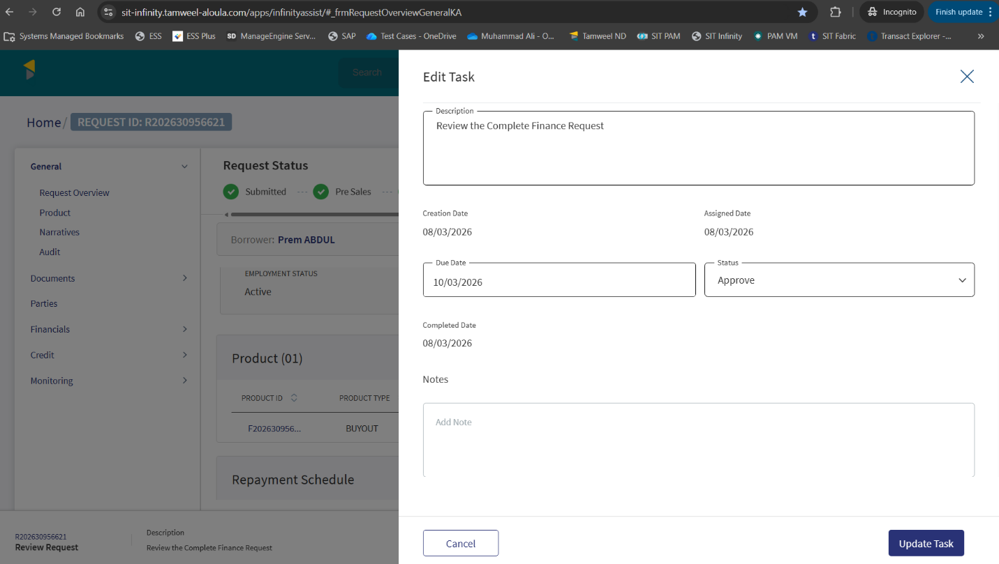
Application approved from L2

Offer Generation
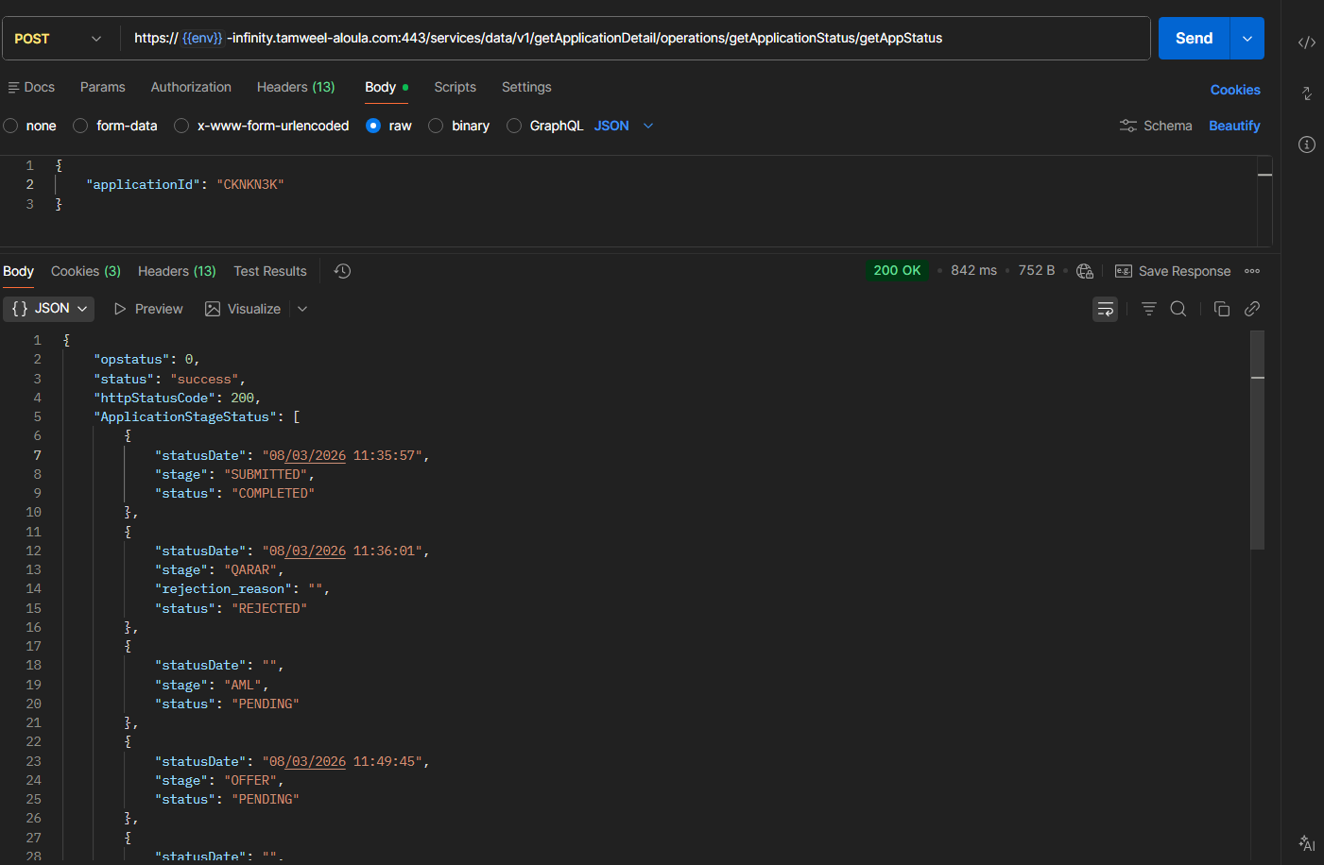
Offer generated

Offer Acceptance
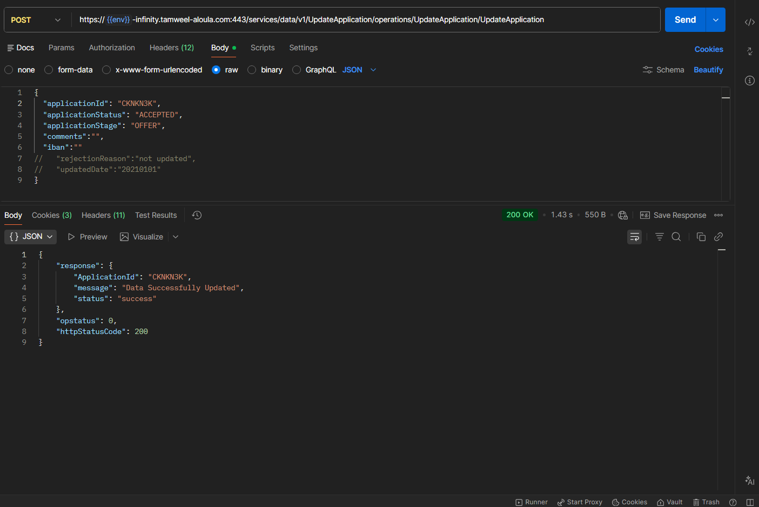
Offer is accepted using API
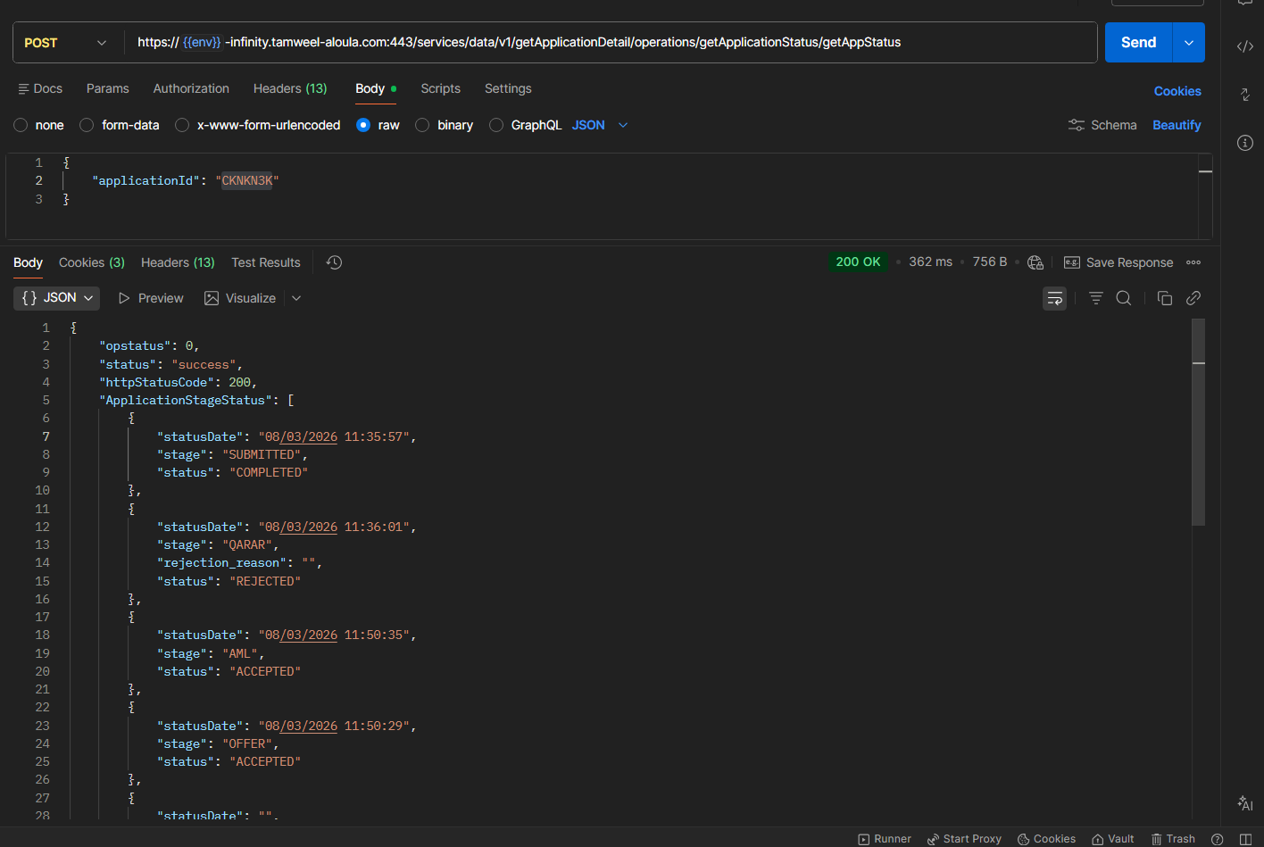
Offer & AML Status is updated

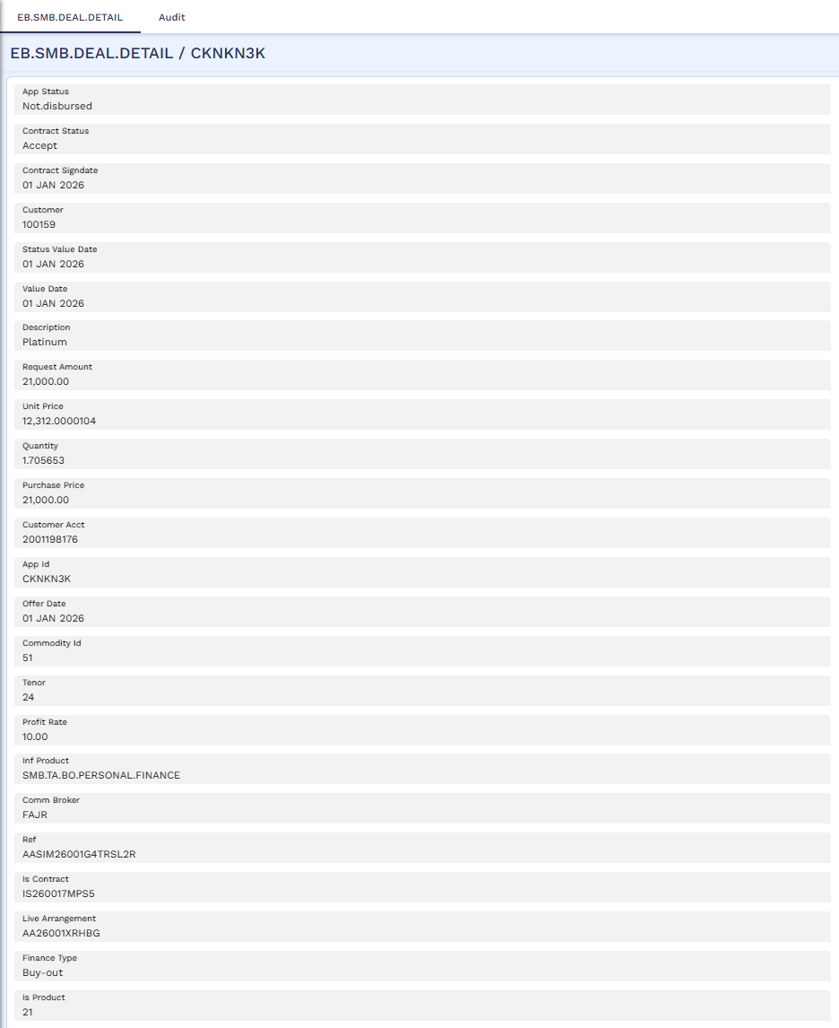
Application Details in Transact
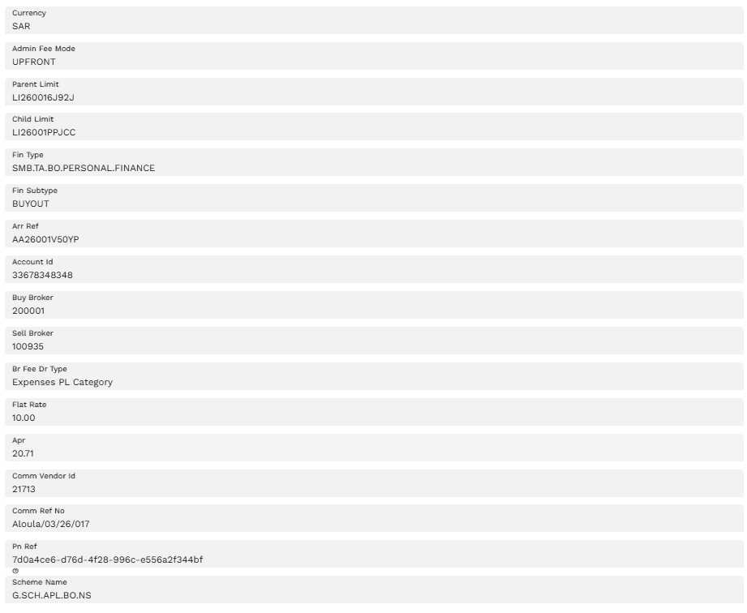
Application landed in Transact

STP Process
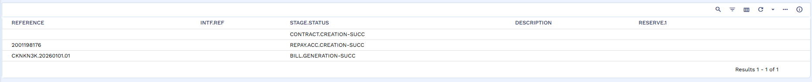
STP process started in Transact

Bill Generation
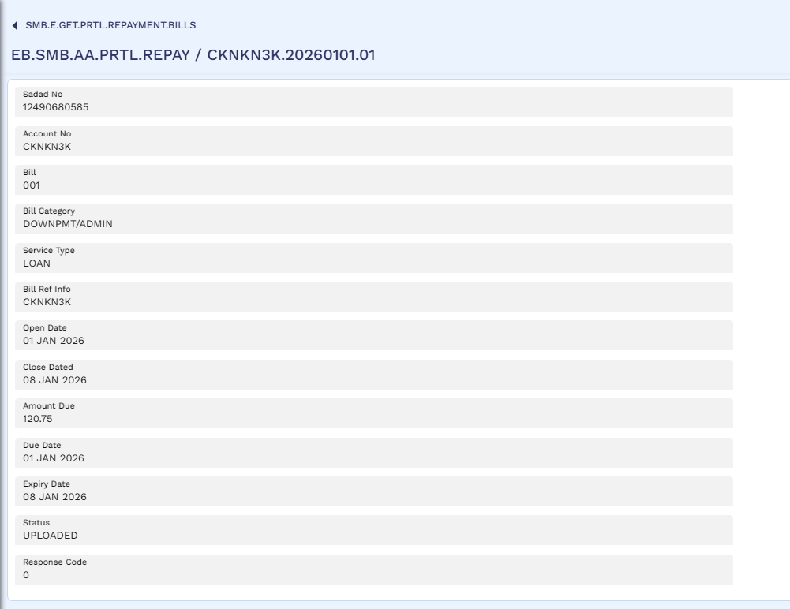
Admin fee Bill generated in Transact

Contract

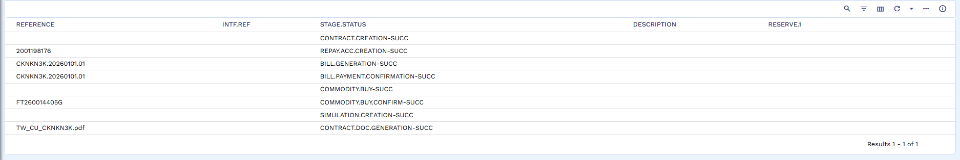
Bill Paid successfully and Contract Generated in Transact

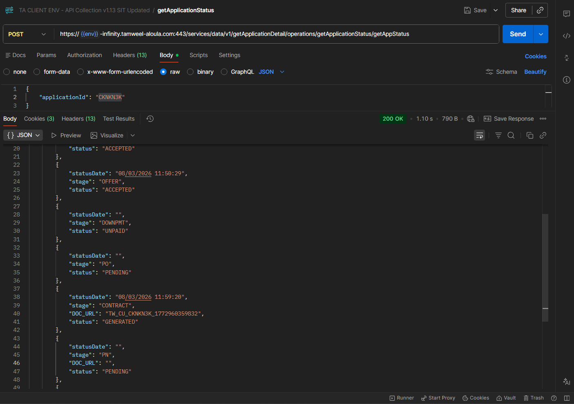
Status updated for Contract stage as “GENERATED”
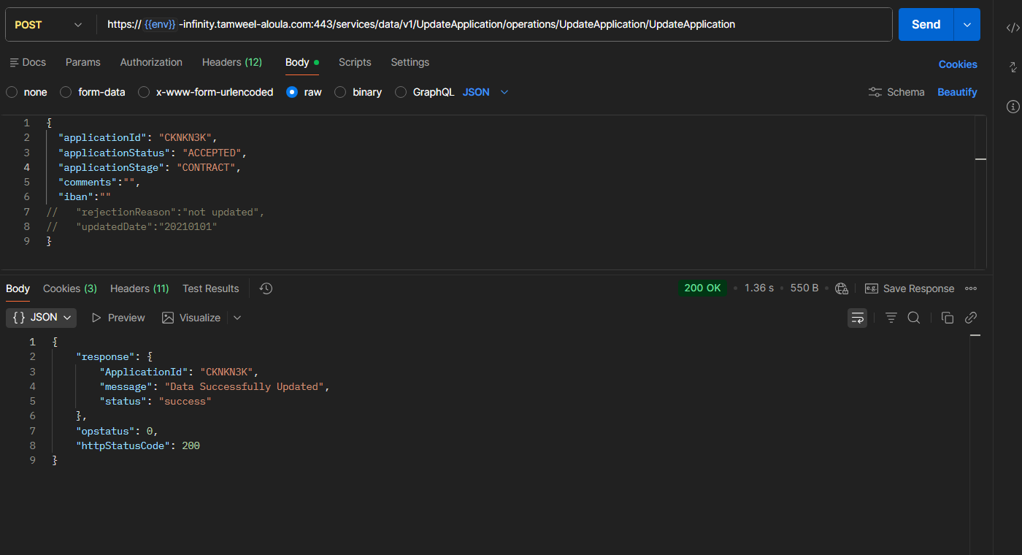
Contract is accepted using API
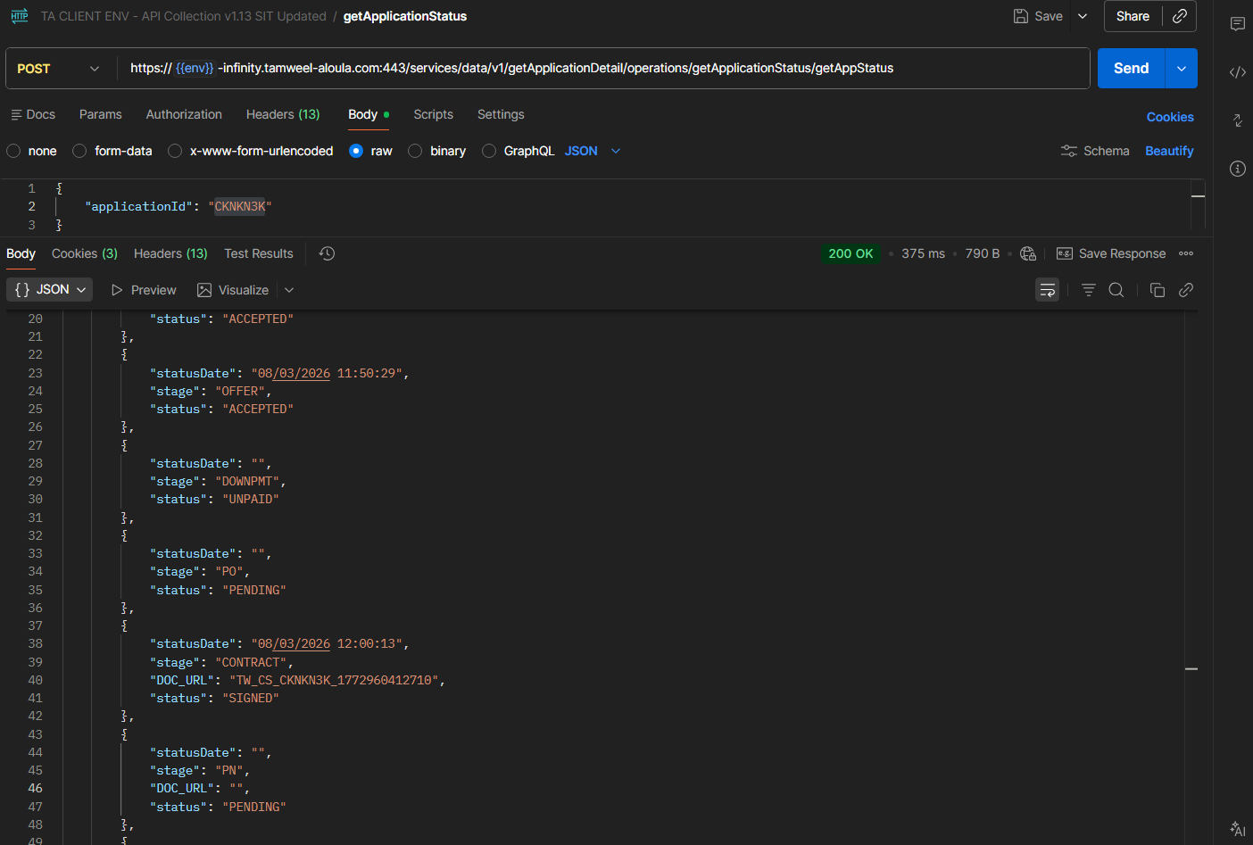
Status is updated as “SIGNED”

Promissory Note
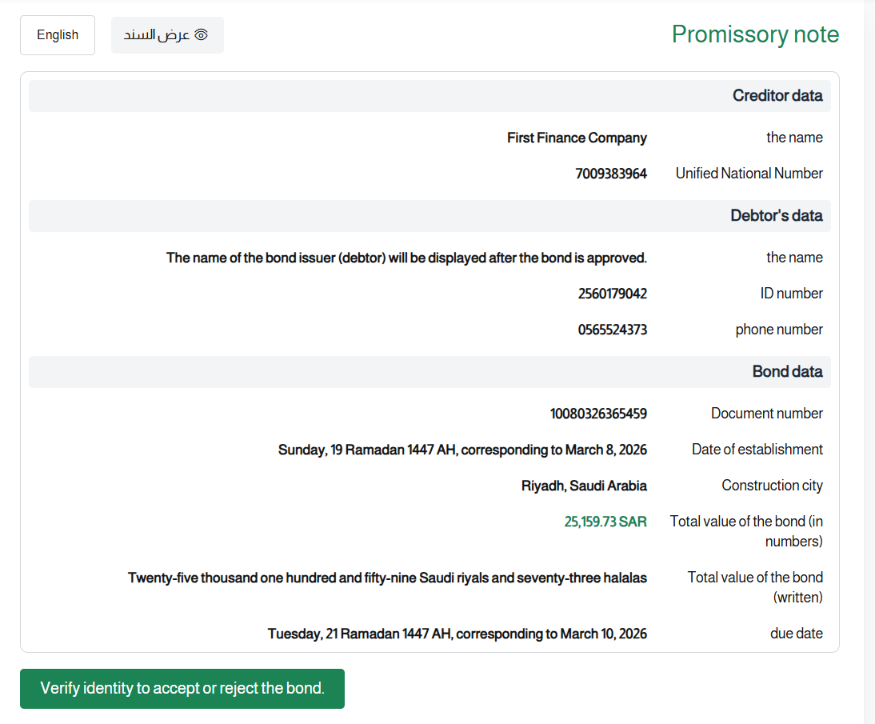

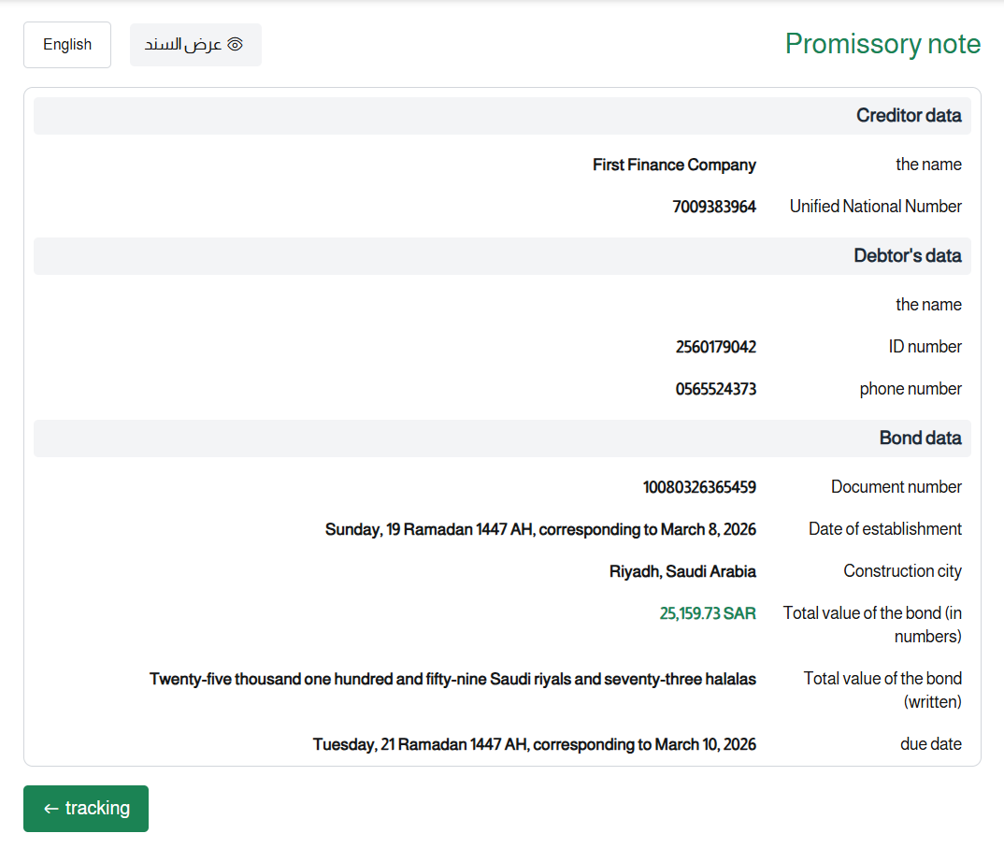
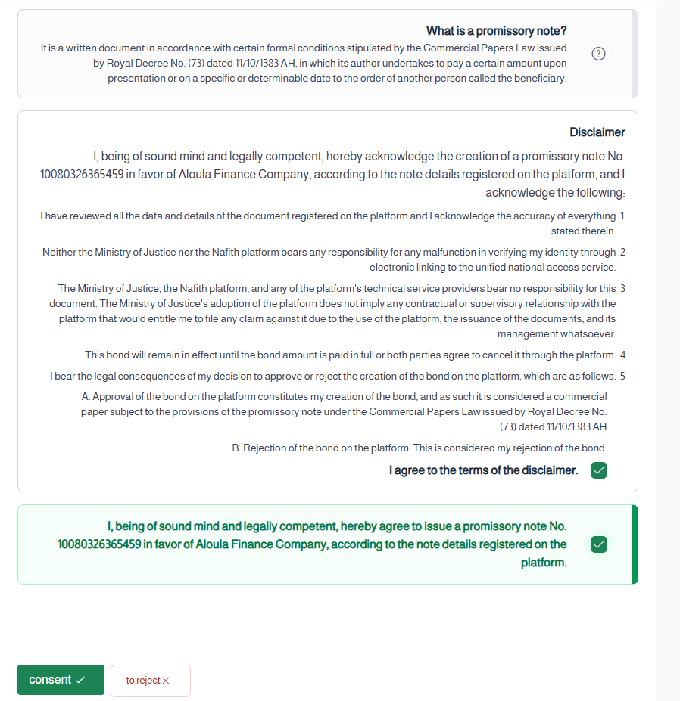
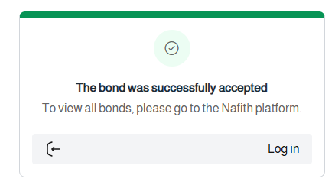
PN accepted

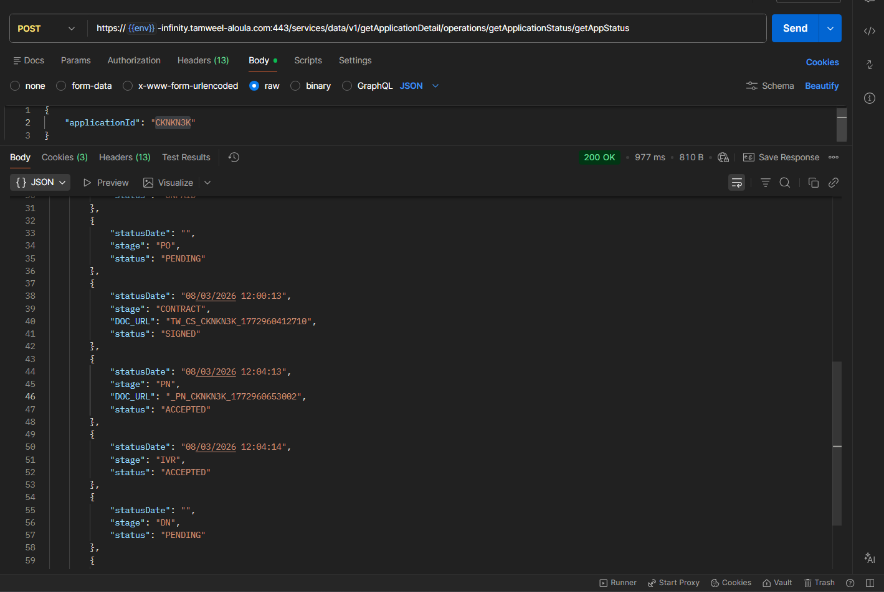
PN status is updated as “ACCEPTED”

STP Complete
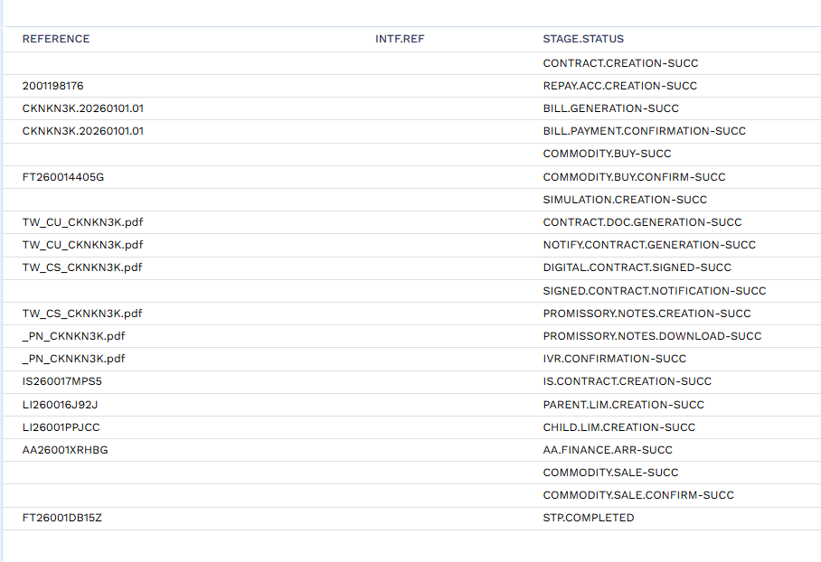
STP successfully complete in Transact

Arrangement
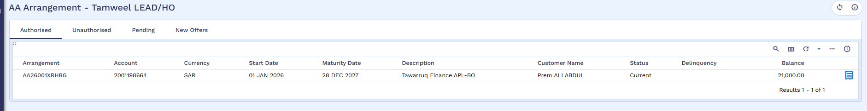
Arrangement created in Transact
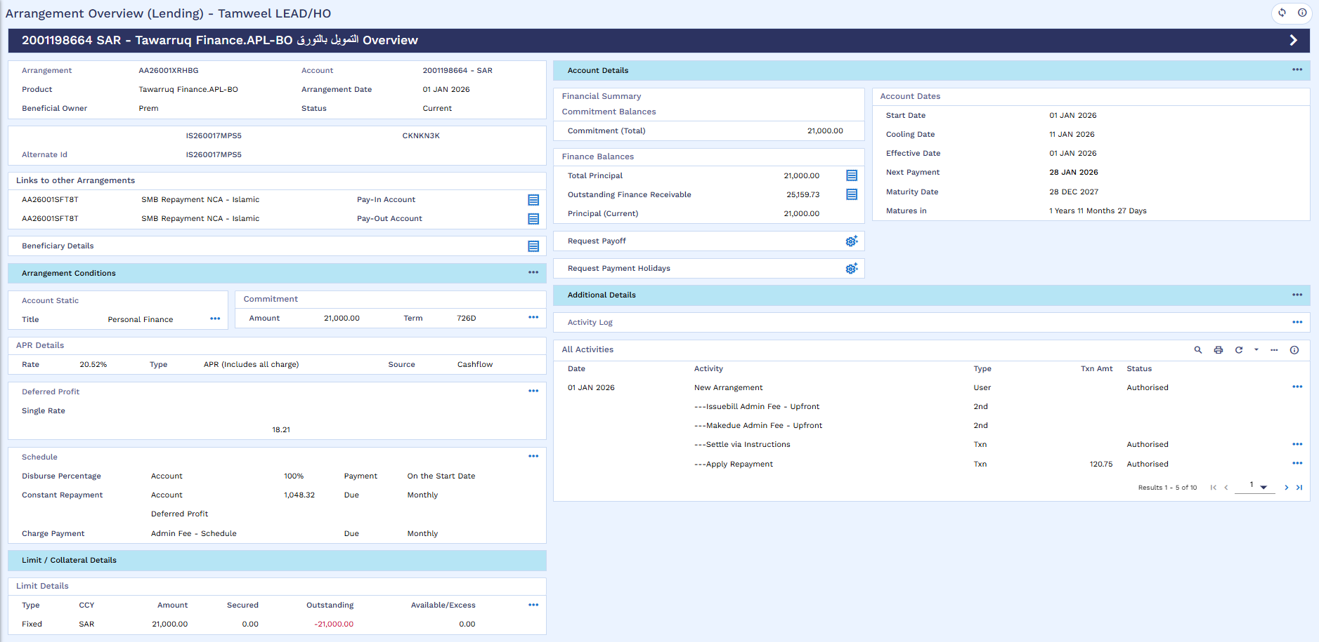
Arrangement 360 overview
Arrangement Accounting Entries 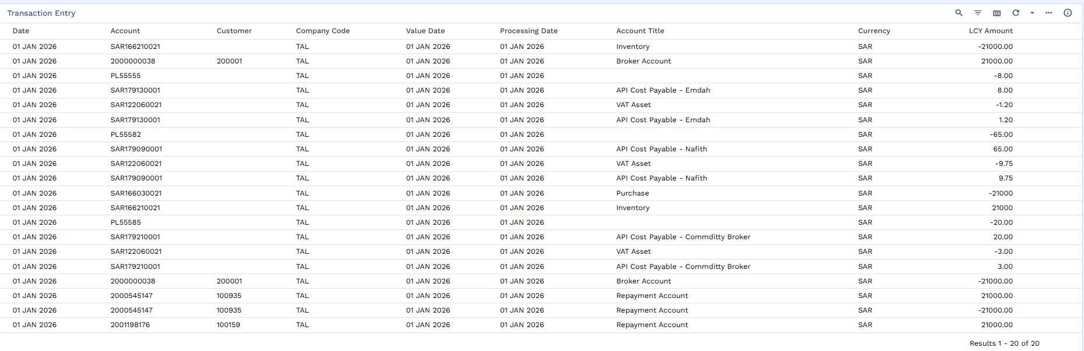
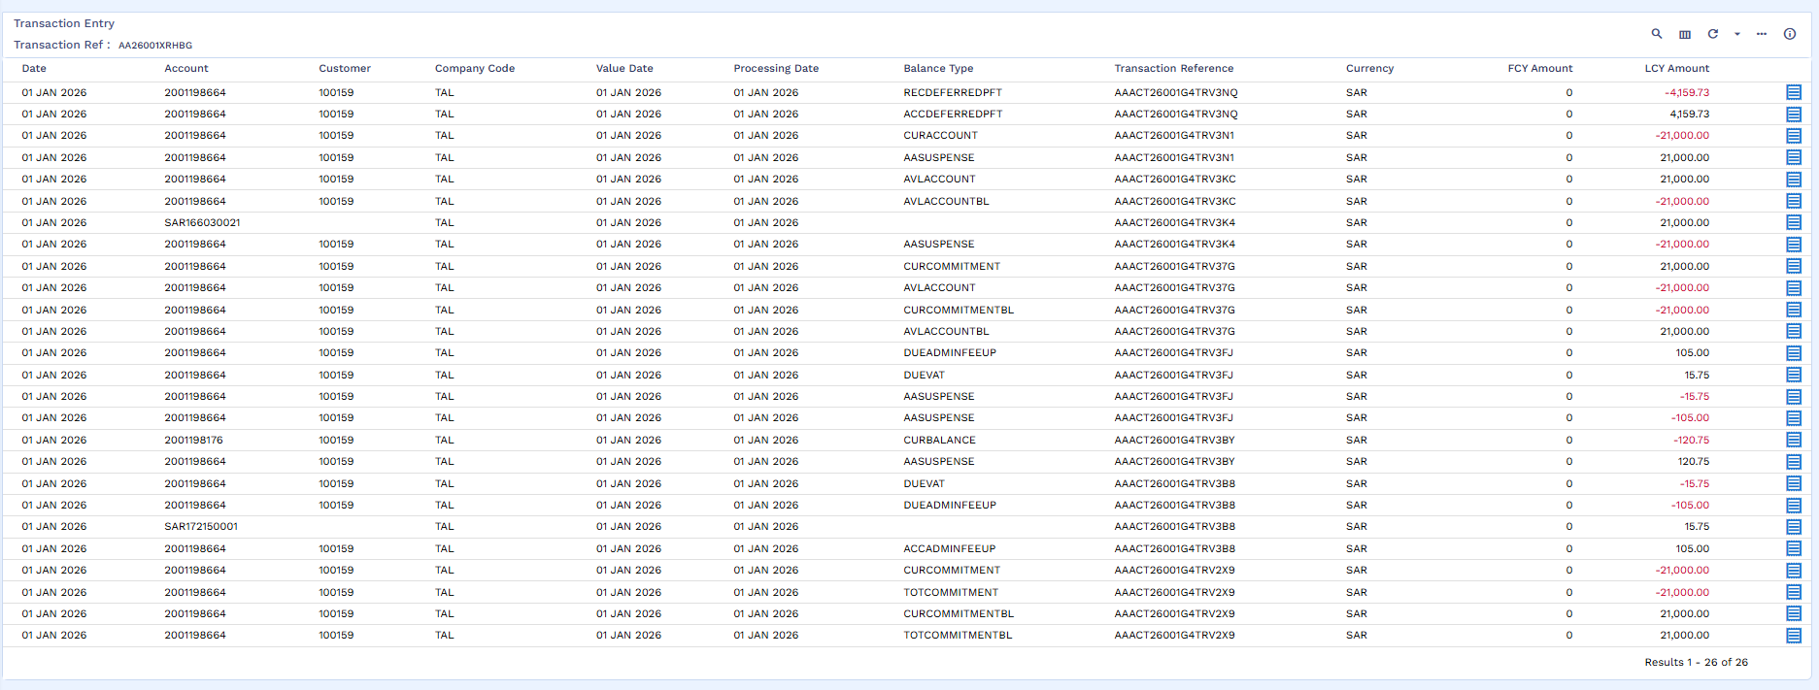
Accounting Entries
Arrangement’s Repayment Account
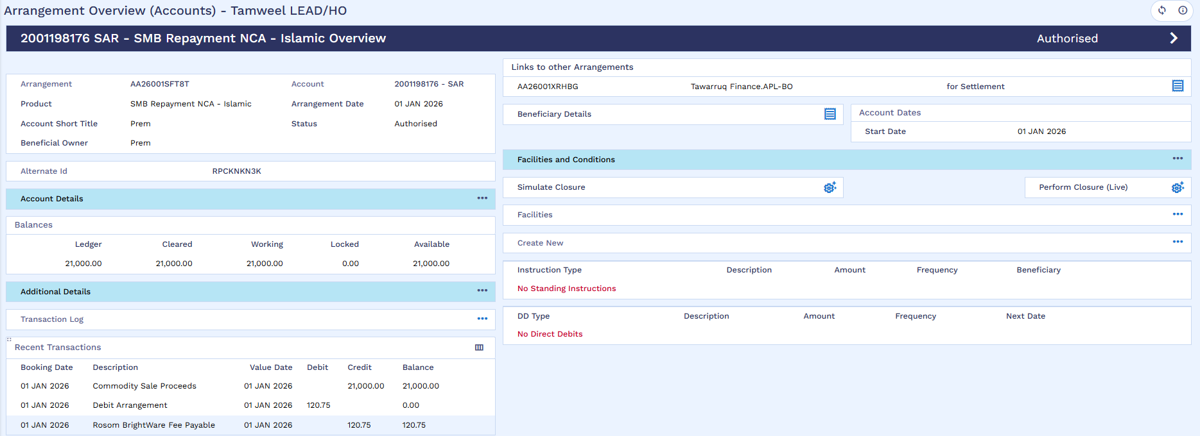
Funds available in AA repayment account

Disbursement
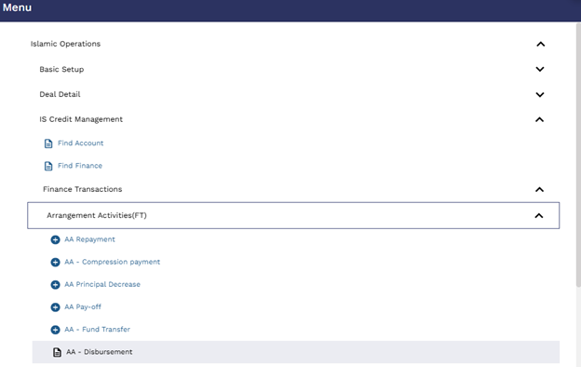
User will go to ?16 AA disbursement
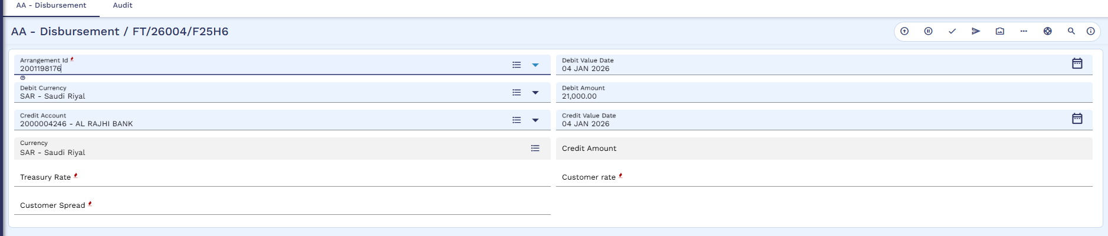
User will initiate FT to transfer funds from repayment account to customer
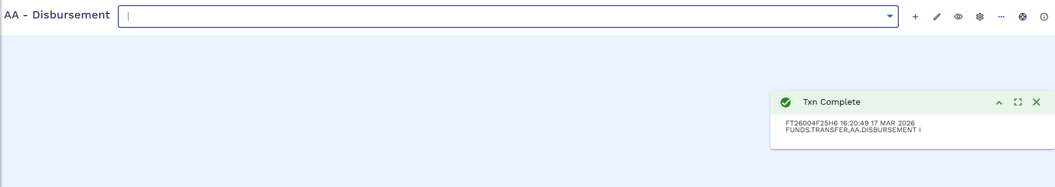
User will commit the record.
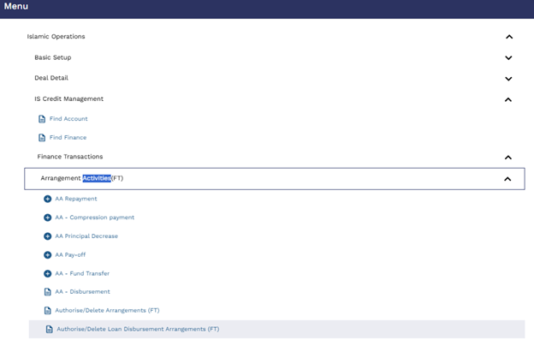
Authorizer will go to ?16 and Authorize / Delete Loan Disbursement Arrangement (FT)
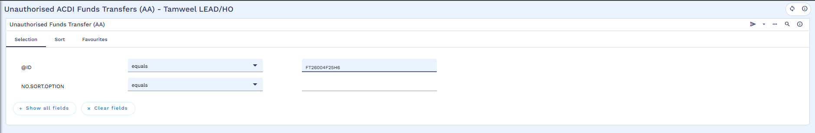
Authorizer will search the FT
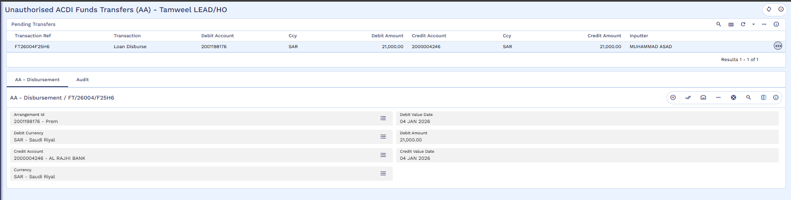
Authorizer will review the records
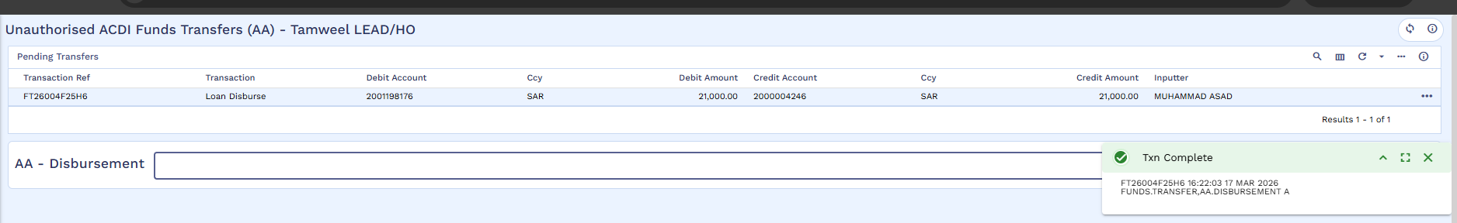
Commit the transaction
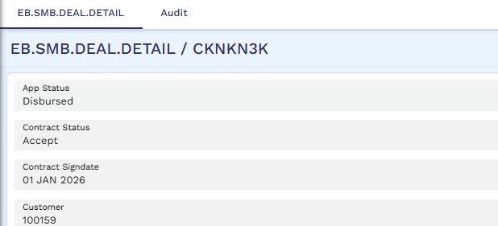
App status has been updated as “Disbursed”

